Provincial Mentoring Framework

MENTORING
Hertfordshire Freemasons
Reference:
Our Reference:
Reviewed by: | Mark Butcher
Prepared by: | Wes Pierce
Version: | 3.1

Prepare, Support, Guide and Enlighten

Revision Status

Date | Status | Author | Revision
01.01.2026 | Concept/Idea | Mark Butcher | 1.1
02.01.2026 | Revision | Wes Pierce | 2.1
03.06.2026 | Revision | Wes Pierce | 2.2
06.09.2026 | Revision | Wes Pierce | 3.1

Table of Contents
Foreword 4
1. Purpose & Vision 5
2. Background & Context 6
3. Guiding Principles 6
4. Team Structure 7
5. Alignment with APGM Lodges 7
6. Appointment of Assistant Provincial Mentors 8
7. Roles & Responsibilities 8
7.1 Provincial Grand Mentor - W. Bro Mark Butcher 8
7.2 Deputy Provincial Grand Mentor - W. Bro Wes Pierce 8
7.3 Assistant Provincial Grand Mentors (TBC - ×5) 9
8. New Initiate Pathway 9
9. Member Learning & Support 10
Guided Learning 10
Personal Learning 10
10. One Journey 11
Mentoring the One Journey 11
How mentoring bridges the gap 11
Practical alignment 11
The retention case 11
11. Retention & Early Intervention 12
12. Communication & Reporting 13

Foreword
“Freemasonry must be fun.”
W. Bro Mark Butcher, Provincial Grand Mentor
Three words. But in those three words lies everything we are trying to do.
When a man presents himself for initiation, he is taking a step into the unknown, guided by curiosity, by friendship, or by a desire to be part of something greater than himself. He does not know what Freemasonry will ask of him. He does not yet know the friendships he will form, the ceremonies he will witness, or the satisfaction that comes from playing his part well. What he does know (what he hopes) is that it will be worth it.
Our responsibility, as mentors and as Freemasons, is to make certain that it is.
That means making a man feel welcome from the moment he walks through the door. It means ensuring he is never left to wonder what happens next, never made to feel inadequate for not knowing something he has never been taught, and never pressured into roles or responsibilities before he is ready. It means giving him the knowledge, the companionship, and the confidence to enjoy every stage of his Masonic journey - not just the first few months of it.
Fun is not a trivial ambition. It is a profound one. A man who is enjoying himself attends. A man who attends participates. A man who participates belongs. And a man who belongs does not resign.
The Provincial Mentoring Team exists to make that chain of belonging as strong as possible across every Lodge in Hertfordshire. With approximately 150-190 new initiates joining our Province each year, the scale of our opportunity is significant, and so is the scale of our responsibility. No new Brother should fall through the cracks. No Lodge should feel unsupported. And no mentor should feel alone in his work.
This strategy sets out how we will organise ourselves to meet that responsibility: through a structured team, clear roles, consistent communication, and a shared commitment to the principles that underpin everything we do - Prepare, Support, Guide and Enlighten.
I am grateful to W. Bro Wes Pierce for the depth of thought and care he has brought to the development of this framework. The strategic plan that underpins this document reflects a genuine understanding of what mentoring is, what it requires, and why it matters.
But the real work lies ahead of us, in the Lodges, in the conversations, and in the relationships that our mentors will build with the men who need them most.
Let us make Hertfordshire a Province where Freemasonry is genuinely, consistently, and unapologetically enjoyable. Where every Brother is glad he joined, proud he stayed, and eager to pass that spirit on to the next man who walks through the door.
Freemasonry must be fun. That is where we begin.

W. Bro Mark Butcher
Provincial Grand Mentor

1. Purpose & Vision
“We do not retain members by design; we build a culture that prepares and supports them - retention follows naturally.”
- W. Bro Wes Pierce, Deputy Provincial Grand Mentor

The Province of Hertfordshire is committed to ensuring that every Freemason who joins our Lodges receives the guidance, support and fellowship that will help him flourish throughout his entire Masonic journey, from interview and initiation, through progression and office, into the Chair and well beyond it. This strategy sets out how a structured Provincial Mentoring Team will be established, resourced and managed to deliver that commitment consistently across all Lodges in the Province.

Our work is underpinned by four core principles:

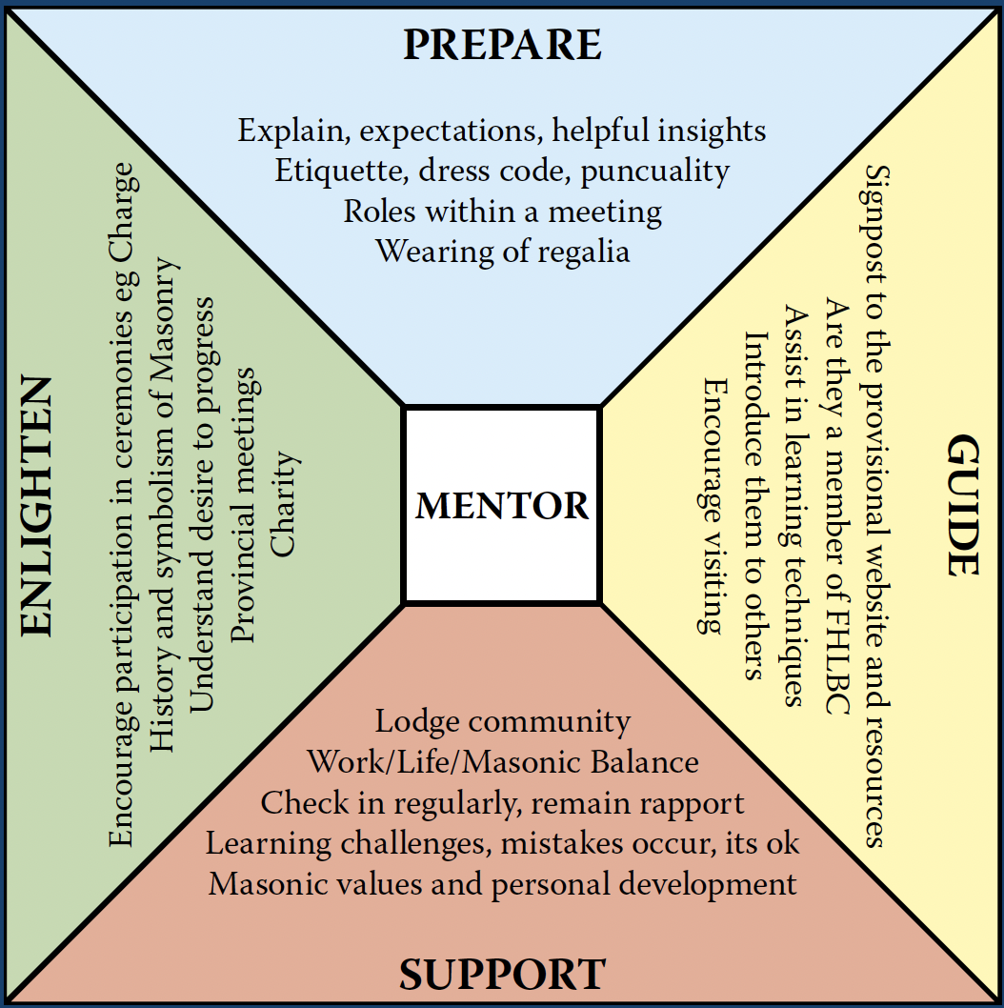

Every action taken by the mentoring team - whether at Provincial or Lodge level - should reflect and reinforce these pillars. This plan asks not ‘How do we keep members?’ but ‘How do we make Freemasonry so rewarding that men never want to leave?’

2. Background & Context
Effective mentoring has been identified by the United Grand Lodge of England (UGLE) as a primary tool for improving retention and member satisfaction. The Province of Hertfordshire welcomes approximately 150-190 new initiates each year, a figure that underlines both the scale of the opportunity and the responsibility we carry. UGLE’s Members’ Pathway places mentoring at the heart of supporting new members, sustaining engagement, identifying disengagement early, and retaining members during periods of change.

Some losses from the Province are inevitable, through illness, age, relocation or changing personal circumstances. However, too many are avoidable, arising not from a lack of goodwill but from men being poorly prepared, insufficiently supported, or inadequately guided during their early years. This strategy exists to change that. It is not about targets or control, but about care, consistency and culture.

Within Hertfordshire, the Province has been served by a Provincial Grand Mentor for a number of years, and in more recent times that role has been supported by an assistant, two officers between them covering 140 Lodges. Through their dedication and commitment, the visibility and profile of mentoring across the Province has grown considerably. That is a foundation to be proud of, and this new structure is not a departure from their work but a natural extension of it.

The formation of a wider, structured team creates the opportunity to build on that momentum, extend the reach of mentoring to every corner of the Province, and bring a more consistent, systematic approach to supporting our members. This mirrors the model already adopted successfully by other areas of Provincial activity, and reflects the growing recognition that mentoring, done well, is one of the most powerful tools we have.

3. Guiding Principles
This strategy is underpinned by the following principles:

- Member-centered: The needs, circumstances and aspirations of the individual member must always remain central to the mentoring process.
- Consistency with flexibility: While standards and good practice should be consistent across the Province, their application must remain flexible to suit individual Lodges and members.
- Lifelong journey: Mentoring extends well beyond initiation and early degrees, supporting members throughout their Masonic life, including periods of progression, transition and change.
- Early intervention: Effective mentoring identifies emerging issues early and addresses them before dissatisfaction becomes disengagement or resignation.
- Enjoyment and satisfaction: Members who enjoy Freemasonry, feel supported, and derive personal value from it are far more likely to remain committed over the long term.

4. Team Structure
The Provincial Grand Mentor acts as the custodian of mentoring standards and quality across the Province. Importantly, the Provincial Grand Mentor does not replace the Lodge Mentor’s role, nor interfere with Lodge governance. The role exists to enable Lodges to succeed in mentoring their members well. The Provincial Mentoring Team will operate under the following hierarchy:

Role | Appointment | Area of Responsibility
Provincial Grand Mentor | W. Bro Mark Butcher | Province-wide strategy & quality assurance
Deputy Provincial Grand Mentor | W. Bro Wes Pierce | Operational co-ordination & Lodge Mentor support
Assistant Provincial Grand Mentor (×5) | TBC | Assigned per APGM area - see Section 5

The Provincial Grand Mentor holds overall responsibility for the mentoring programme, reporting directly to the Provincial Grand Master. The Deputy Provincial Grand Mentor provides operational day-to-day management and acts as the primary point of contact for Assistant Mentors. Each of the five Assistant Provincial Mentors is aligned to one of the five APGM areas.

5. Alignment with APGM Lodges
To ensure clear accountability and a manageable span of responsibility, each Assistant Provincial Mentor will be aligned to one of the five APGM areas within the Province. With approximately 150-190 new initiates joining the Province annually, each area will typically see around 30-40 new Brothers each year - a figure that reflects the importance of having a dedicated mentor presence in every part of the Province.

APGM Area | Asst. Provincial Mentor | Assigned Lodges
Area 1 | TBC | To be assigned on appointment
Area 2 | TBC | To be assigned on appointment
Area 3 | TBC | To be assigned on appointment
Area 4 | TBC | To be assigned on appointment
Area 5 | TBC | To be assigned on appointment

Lodge lists for each area will be circulated to appointed Assistant Mentors at the commencement of their role. The Deputy Provincial Grand Mentor will maintain a central register and will review annually to ensure equitable workloads across the team.

6. Appointment of Assistant Provincial Mentors
Candidates for the role of Assistant Provincial Mentor should:

- Hold the rank of Master Mason and be in good standing with their Lodge
- Have a demonstrated interest in, or experience of mentoring support
- Be willing to undertake mentor training and any Province-specific development
- Be able to commit sufficient time to visit Lodges and support new members in their area
- Possess strong interpersonal and communication skills

Nominations should be submitted to the Provincial Grand Mentor (W. Bro Mark Butcher) via the Deputy Provincial Grand Mentor (W. Bro Wes Pierce). All appointments are subject to the approval of the Provincial Grand Master.

7. Roles & Responsibilities

7.1 Provincial Grand Mentor - W. Bro Mark Butcher
- Set the strategic direction and standards for Provincial mentoring, guided by the mantra: Prepare, Support, Guide and Enlighten
- Act as the custodian of mentoring standards and quality across the Province
- Chair the Provincial Mentoring Team and convene at least two team meetings per year
- Liaise with the Provincial Grand Master and Provincial Executive on all mentoring matters
- Work collaboratively with the Provincial Grand Membership Officer to align mentoring with recruitment, retention, retrieval and migration activity
- Monitor mentoring effectiveness at a Provincial level and provide regular reports to the Provincial Executive
- Report annually to Provincial Grand Lodge on the progress and impact of the mentoring programme

7.2 Deputy Provincial Grand Mentor - W. Bro Wes Pierce
- Co-ordinate the day-to-day activities of the mentoring team
- Maintain a register of Lodge Mentor appointments and ensure continuity across the Province
- Oversee the distribution of welcome communications to all new initiates, through an administrative support assistant.
- Support Assistant Mentors with training, resources and problem-solving
- Collate and submit mentoring statistical returns, feeding into the annual overview report
- Deputise for the Provincial Grand Mentor in his absence
- Manage the onboarding of new Assistant Provincial Mentors
- Organise and facilitate periodic Lodge Mentor meetings, including the monthly mentoring call

7.3 Assistant Provincial Grand Mentors (TBC - ×5)
- Establish and maintain contact with Lodge Mentors within their designated APGM area
- Support Lodge Mentors in engaging with the approximately 50 new initiates typically joining each area per year, ensuring every new Brother receives timely and meaningful guidance
- Provide a direct link between the Provincial mentoring team and individual Lodges, reinforcing the complementary roles of Lodge Mentors, Membership Officers and other support officers
- Attend Lodge meetings as appropriate to observe mentoring activity and offer guidance, ideally at initiations to greet the new members.
- Encourage Lodges to appoint Lodge Mentors willing to serve for a sustained period - ideally three to five years - and promote orderly handover arrangements when Lodge Mentors change
- Submit quarterly reports to the Deputy Provincial Grand Mentor

8. New Initiate Pathway
The Province recognises that the period immediately following initiation is critical to a Brother’s long-term engagement with Freemasonry. The following touchpoints form the core of the Provincial new-initiate pathway:

- Welcome Letter: A personally addressed letter is emailed to every new initiate shortly after their initiation. The letter introduces the Provincial mentoring team, outlines the support available, and encourages the Brother to engage with his Lodge Mentor and the wider Provincial resources.

- Combined Mentoring and Learning and Development Meeting: Each new initiate is invited to attend one of two annual Provincial events that bring together the mentoring and Learning and Development functions. Held twice yearly, these meetings provide a welcoming environment in which new Brethren can deepen their understanding of Freemasonry, meet fellow initiates from across the Province, and connect with experienced mentors.

- Mentoring and Membership Past Masters’ Lodge: Meeting twice annually, this Lodge provides a formal mechanism for communication, alignment and recognition in support of mentoring, membership development and educational delivery.

- Mentor Jewel Presentation: The explanation of the Mentor’s Jewel will be delivered to all persons formally appointed to the role of Lodge Mentor, reinforcing the significance and responsibilities of the position.

- Ceremony Spotlight: Each year, the Mentoring Team will select three exemplary ceremonies: a First, Second, and Third Degree, to feature in The Visitors' Festival, a Provincial Mentoring initiative. A host lodge will be identified for each, with the ceremony taking place as part of its existing calendar. Newly initiated, passed, and raised brethren will be encouraged to attend as visitors, seated alongside the Provincial Mentoring Team to observe and explore the ceremony together.

9. Member Learning & Support
Effective mentoring requires a balanced approach to learning that combines structured guidance with personalised, continued support throughout a member’s Masonic journey.

Guided Learning
Guided learning equips members to participate confidently in Lodge life, understand degrees, structure and protocols, and progress appropriately when they choose to do so. It should be planned, accurate, delivered by those suitably experienced, and reinforced through mentoring support.

Personal Learning
Personal learning is ongoing throughout membership, led by the member’s own interests and curiosity. It is supported primarily through one-to-one mentoring and is a key contributor to long-term satisfaction and retention.

Lodge Mentors will be guided to make appropriate use of authoritative resources - including Solomon, UGLE’s online learning platform, and approved Provincial materials, while ensuring that technology never becomes a barrier to learning. Printed materials and face-to-face conversations remain equally valued.

The strategy also reinforces the importance of protecting members from undue pressure: no member should feel pressured to accept office, deliver ritual or progress prematurely. The approach to the Royal Arch should similarly emphasise timing and clear information rather than recruitment, ensuring members are ready and fully informed of the next steps.

10. One Journey

Mentoring the One Journey
The purpose of One Journey is education and timing, not pressure. As Section 9 already sets out in respect of the Royal Arch, our role is to ensure members are ready and fully informed of the next steps, never to push a man toward exaltation before it is right for him. UGLE is explicit that forcing the issue is counterproductive. The mentoring task is therefore to:
- Make the four-stage journey clear and visible from initiation, so the Royal Arch is never a surprise.
- Present the Royal Arch as completion and enrichment of the Craft journey, not as “another order” competing for a Brother’s time.
- Leave the decision, and its timing, with the member.
This protects against the most common failure point: a Brother who reaches the Chair having never had the Royal Arch explained to him, and who then perceives it as a sales pitch rather than the natural close of the path he began on his initiation night.

How mentoring bridges the gap
The gap One Journey addresses is the disconnect many members feel between Craft and Chapter, treating them as two memberships, two diaries, two sets of friends. Mentoring closes that gap at four points:
- At initiation - the Welcome Letter and the Lodge Mentor’s early conversations frame Freemasonry as a four-part journey from the start.
- Through progression - as a Brother is passed and raised, his mentor references where each step sits in the wider journey, so the Royal Arch is anticipated, not introduced cold.
- Around the Master Mason degree - UGLE’s clear encouragement is for Master Masons to complete the journey in pure Antient Masonry before joining other orders. The mentor’s job is to ensure the Brother knows this, and knows that it is his choice to make when ready.
- Through the Royal Arch representative - every Craft Lodge has one. Mentoring should work with the RA representative.

Practical alignment
- The Provincial Mentoring Team should coordinate with the Provincial Grand Chapter / Second Provincial Grand Principal so that “One Journey” messaging is shared, not parallel. A bridge built from only one side does not meet in the middle.
- “Archway” - UGLE’s developing resource of Royal Arch good practice - should be referenced alongside Solomon in the Member Learning & Support section, giving Lodge Mentors authoritative material to draw on.

The retention case
This is not heritage for its own sake. Members who join the Royal Arch are demonstrably more likely to remain engaged with their Craft Lodges. “One Journey” therefore serves the same end as the rest of this framework: a Brother who sees a path ahead of him stays; one who believes he has reached the end of the road is the one most at risk. Completing the journey gives the long-serving Master Mason a reason to remain active and engaged.

11. Retention & Early Intervention
Retention is not treated as a numerical target, but as the natural outcome of members who feel supported, valued and satisfied. Effective mentoring is a preventive activity as much as a supportive one, with retention embedded in everyday mentoring conversations through listening, empathy and timely support.
Lodge Mentors will be supported to recognise the early warning signs of disengagement:

Attendance Patterns
- Missed two or more consecutive meetings without explanation
- Arrival late or leaving early becoming habitual
- Attendance only at Installations or social events
- Stopping visiting other Lodges

Participation Changes
- Reluctance to accept or prepare for work
- Reduced engagement in Lodge conversations
- Minimal participation in social activities
- Absence from rehearsals when in office

Communication Indicators
- Not responding to Lodge or Personal Mentor contact
- Expressing frustration or disappointment
- Mentioning financial or time pressures repeatedly
- Comparing unfavourably with expectations or other organisations

When warning signs are identified, the following early intervention process should be followed. The emphasis throughout should be on compassionate enquiry, not interrogation - the question is ‘How can we help?’ not ‘Why aren’t you attending?’

Step 1: Personal Mentor makes friendly, informal contact
Step 2: Lodge Mentor becomes involved if concern continues
Step 3: Worshipful Master or other appropriate officer has a conversation
Step 4: Referral to Provincial support if needed

Where a member indicates an intention to resign, the Lodge should seek to understand the underlying reasons, offer the member an opportunity to reconsider where appropriate, and explore alternatives such as reduced involvement or Lodge transfer. Where resignation proceeds, the process should preserve goodwill and maintain future pathways for re-engagement.
Relocation presents both a retention risk and a clear opportunity. The Provincial Grand Mentor will support the Member Migration Process, encouraging early identification of members planning to relocate and proactive engagement before resignation is considered. Migration is treated as a continuation of mentoring, not an administrative exercise.

12. Communication & Reporting
A clear communication framework will underpin the team’s effectiveness:
- Monthly mentoring call, facilitated by the Deputy Provincial Grand Mentor, open to all Lodge Mentors
- Quarterly returns from each Assistant Mentor detailing Lodge engagement and new-initiate support activity
- Bi-annual Provincial Mentoring Team meetings (in person wherever possible)
- Annual overview report from the Provincial Grand Mentor to the Provincial Executive, covering mentoring health, key themes, risks, good practice and recommended actions
- Awareness and reporting within the Provincial newsletter

Where appropriate, anonymised feedback and thematic findings may be shared with Lodges to support reflection and improvement without attributing blame.



Hertfordshire Provincial Grand Lodge
Fleet House
10 Parkway
St Albans
AL3 6PA

01727 833061
www.pgherts.org

